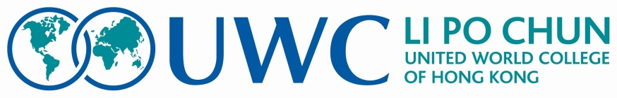

Dear Sir/Madam,

Greetings from Li Po Chun United World College of Hong Kong.

The letter below is written by our Initiative For Peace (IFP) group which I fully support.

“The IFP group is planning its 11th annual conference. This year’s conference is called ‘Hong Kong Diversity Youth Summit’ (IFP-HKDYS). The Summit will be held during last week of May 2016 for 5 days from 26th to 30th May 2016.

At this summit, we wish to bring together about 40-50 Hong Kong youth belonging to all ethnicities including the local Hong Kong students, who believe in a diverse community and wish to work for the cause over a long period. We would like to work mostly with young adults from an age group of 15-19 years.

Details about IFP and the work we have done in the past and the format for application is also included with this letter. We would like you to kindly display this on your notice board and also encourage students from your School/College to apply online by filling the application form in our webpage (http://initiativeforpeace.wix.com/initiativeforpeace). The application deadline is 28th of February 2016.

Participants will be selected based on their enthusiasm to work on this issue and their related views expressed through their application.

The participants will be expected to stay on campus during the 4 nights starting from 26th May. Our college will provide food and accommodation. To have least disruptions for the attending students from your institution, two of the days will be weekend days. We hope that you will be able to spare the attendance of selected students from your institution for the 3 days. If you have any enquiries kindly bring it to our notice via our email ifpuwc@gmail.com.

We will inform your office about the selected participants via email by Mid-April 2016.

We sincerely hope that you will support this noble cause for a better future of Hong Kong.”

In Peace,

Arnett Edwards
Principal

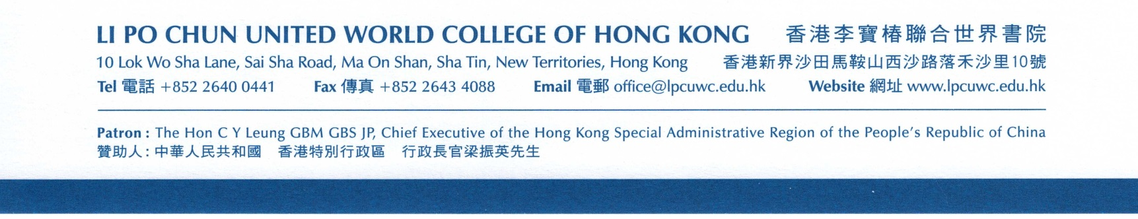

Initiative For Peace (IFP)
Li Po Chun United World College of Hong Kong

Founded 10 years ago, Initiative For Peace (IFP) is a student organization that is supported by a teacher supervisor Mr. Magan Savant at Li Po Chun United World College of Hong Kong. IFP aims to make education a force to unite people, nations and cultures for peace and a sustainable future, in line with the mission of our College and UWC Organization. There are such 14 colleges across the world that believes in ideals of peace.

Our facilitators come from different nations across the world and currently represent 20 different countries. Diversity is a key value not only in the composition of our group but also for the heart of the activities that we conduct. For this reason, IFP stands as a strong advocate of diversity and social inclusion in societies. In order to be able to work for this cause effectively, at the beginning of the academic year, each and every facilitator of IFP undergoes both practical and theoretical training under the supervision of experienced facilitators in an attempt to be equipped with the tools necessary for facilitation.

Through working closely with students in Hong Kong, as well as abroad, IFP aims to bring out the potential of these young adults to function as peacemakers and peacekeepers in their societies. In Hong Kong, IFP regularly hosts students from different schools in day camps. Through facilitating Conflict Management and Resolution activities, IFP facilitators strive to enhance participants’ knowledge and application of conflict management theory to lives in everyday contexts such as school. Majority of the themes highlighted in these activities draw ideas from the core concepts of peace, such as diversity, communication, collaboration and coexistence.

In the past, IFP has organized a total of 10 annual conferences, three with the focus on Kashmir Conflict and six on Mindanao Conflict and the 10th focused on Diversity in Hong Kong. These conferences were conducted with the participation of young leaders from those communities. This May, our conference focuses again on Diversity in Hong Kong. The Initiative for Peace Hong Kong Diversity Youth Summit (IFP-HKDYS) will last for 5 day and will invite secondary school students and early University students, who are residing in Hong Kong. We would like you to encourage your students to apply, who would be passionate about necessity of diversity in Hong Kong. Similarly, students can also apply through our webpage. You can find more information about the application procedure in http://initiativeforpeace.wix.com/initiativeforpeace

Participants will be selected based on leadership skills, enthusiasm and interest in peace, conflict resolution, intercultural understanding and views about diversity. Basic knowledge of both English & Cantonese will be an added advantage.

Benefits to the student participants

The benefits are many folds. It will not only help the participant in adding to personality development but make them aware that it is linked with society building.

To put it in context with the NSS curriculum that came into effect among several Hong Hong schools, OLE (Other learning Experiences) forms an important part.

The proposed HKDYS should definitely add to the ‘Whole Person Development’. As it appears, it should contribute to at-least 3 of its areas if not all 5. Moral and Civic Education, Community Service and Career related experiences will be covered through the summit through almost all Principles mentioned while designing the NSS curriculum.
At the summit, we will be exploring ‘Diversity’ as one of the important needs of a society, that is now being talked over the world and has been actively used in various areas of governance and planning by several governments at many levels.
Among the 7 principles underlying the 5 areas as mentioned, we see that we should be able to cover all of them as explained below.
- Filling the ‘gaps’: ‘Diversity’ being a relatively new concept over the world, it will not only fill the ‘gap’ but give an idea and constructive plans to build on using Diversity as a society building tool.
- Active Engagement: Students will learn activities as well as background to how they can be a part of a constructive engagement in a robust construction of society.
- Opportunity: HKDYS will be an opportunity to learn and acquire tools and skills for an active society building.
- Quality: Students study various academic subjects at their school. This will be an opportunity for them to apply their knowledge to social, cultural, business, ecological and political aspects of everyday life.
- Coherence: The summit works on the principle that all of us have knowledge (particularly even better among Hong Kong students) and summit will help them to connect their knowledge to the everyday life in Hong Kong.
- Flexibility: This is a key word of modern life. What makes us tolerant of others despite having differences in various areas of life. How flexibility in life helps us prosper. The summit will not only provide the skills of acquiring those qualities but also help the participants being able to share those with their fellow students, citizens etc.
- Learning together: We take this quite a bit further by the fact that learning together helps us to being collaborative, tolerant and appreciative of fellow citizen. We will be actively discussing the underlying concepts through simulations, discussions and input from experts from various related areas of diversity.

